# Introduction to programming and robotics with the BBC micro:bit

*An increasing number of universities and employers see successful completion of a computer science course as a sign of academic well-roundedness.*

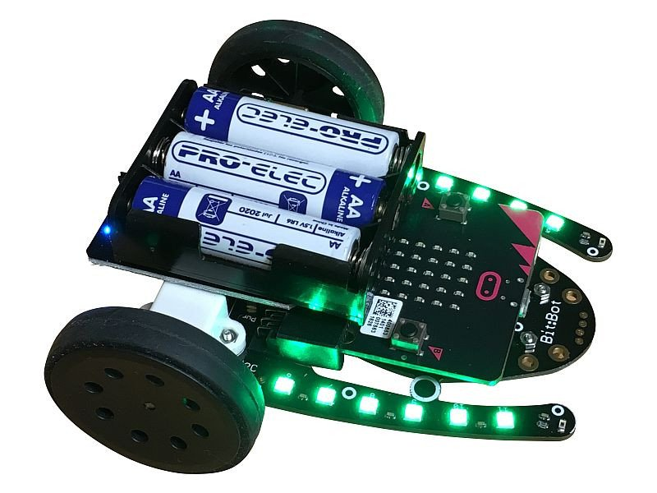– The Association of Computing Machinery

This project introduces the popular python programming language and aims to teach the basics of interacting with electrical components. After mastering the micro:bit embedded system (a very small computer, widely used for computer science education in the UK), students will go on to program the bit:bot robotic car. At the end of the project, students can team up and test their newly learned skills by solving a set of challenges and competing against each other.

Bit:bot robotic car

The project is accessible to students with little or no programming experience.

